How does the web work ?

The browser sends an HTTP request message to the server, asking it to send a **copy of the website** to the client (you go to   
the shop and order your goods). This message, and all other data sent between the client and the server, is sent across your internet connection using TCP/IP.

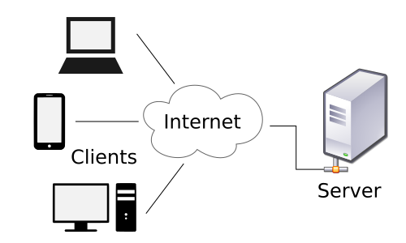



wath do you need to de a web developer ?

Showing results for [***what*** do you need to ***be*** a web developer ?](https://www.google.com/search?sxsrf=ALeKk01OlQjEdMkMy5ZDvbfUPaQqdzTJTQ:1628857773737&q=what+do+you+need+to+be+a+web+developer+?&spell=1&sa=X&ved=2ahUKEwjAvPiHgK7yAhXpAGMBHYztCNoQkeECKAB6BAgBEC8)

Search instead for [wath do you need to de a web developer ?](https://www.google.com/search?sxsrf=ALeKk01OlQjEdMkMy5ZDvbfUPaQqdzTJTQ:1628857773737&q=wath+do+you+need+to+de+a+web+developer+?&nfpr=1&sa=X&ved=2ahUKEwjAvPiHgK7yAhXpAGMBHYztCNoQvgUoAXoECAEQMA)

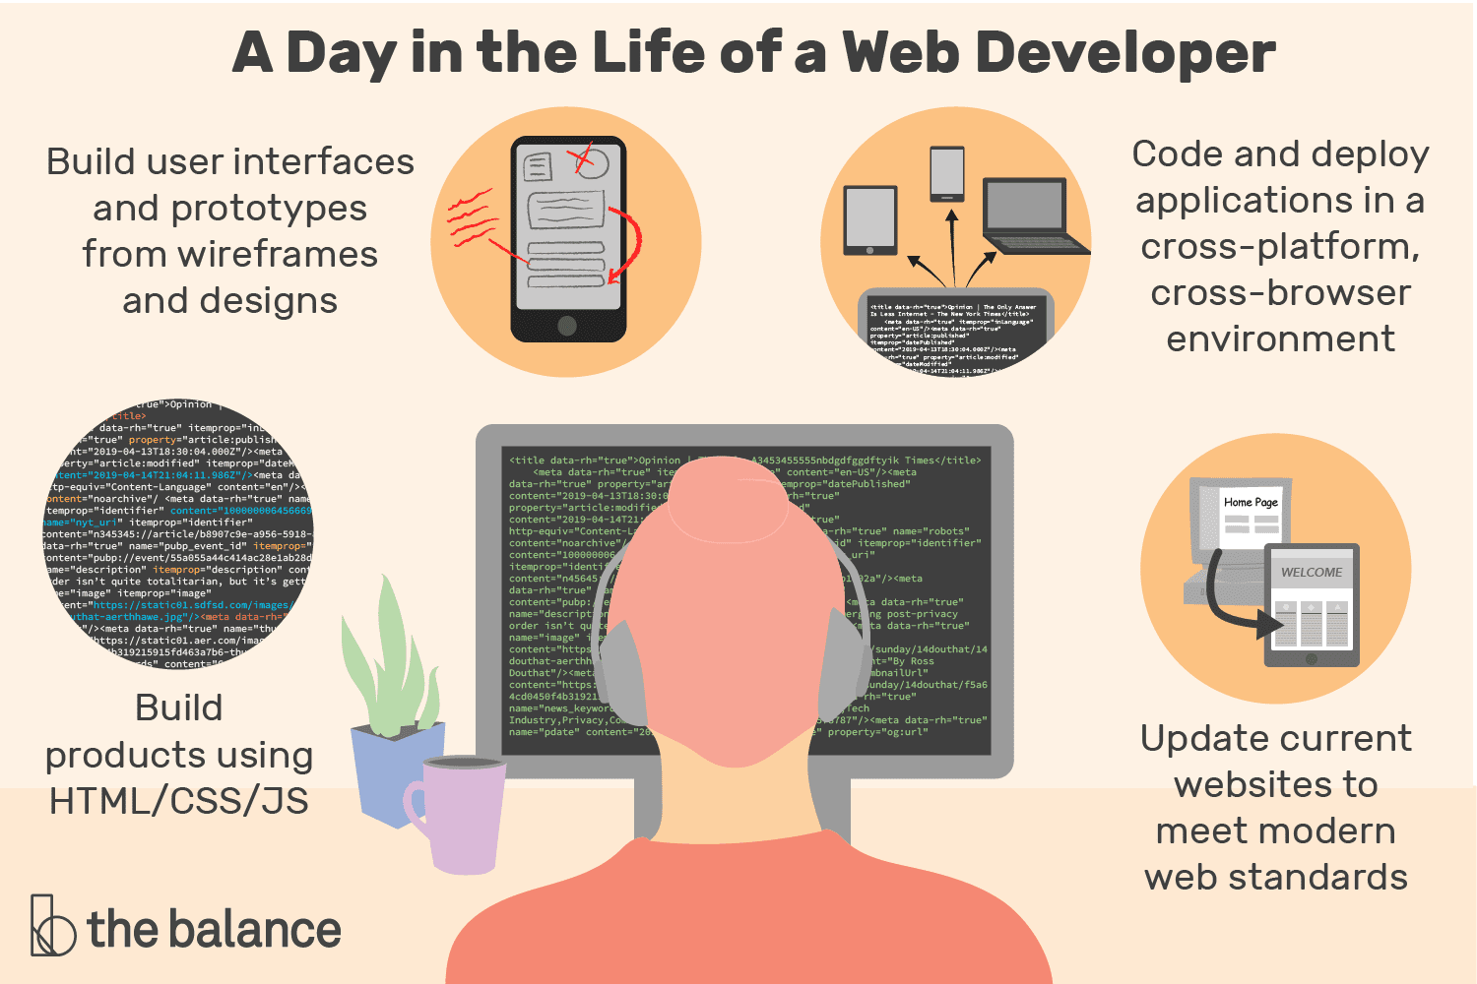

wath is the role of a web developer.

Showing results for [***what*** do you need to de a web developer ? Showing results for what do you need to be a web developer ? Search instead for ***what*** do you need to de a web developer ?](https://www.google.com/search?bih=757&biw=1440&hl=en&sxsrf=ALeKk00qvAsDxODz0pYqJQLShjkS5yf79w:1628858888176&q=what+do+you+need+to+de+a+web+developer+?+Showing+results+for+what+do+you+need+to+be+a+web+developer+?+Search+instead+for+what+do+you+need+to+de+a+web+developer+?&spell=1&sa=X&ved=2ahUKEwiPraybhK7yAhU6C2MBHTv8D9kQkeECKAB6BAgBEC8)

Search instead for [wath do you need to de a web developer ? Showing results for what do you need to be a web developer ? Search instead for wath do you need to de a web developer ?](https://www.google.com/search?bih=757&biw=1440&hl=en&sxsrf=ALeKk00qvAsDxODz0pYqJQLShjkS5yf79w:1628858888176&q=wath+do+you+need+to+de+a+web+developer+?+Showing+results+for+what+do+you+need+to+be+a+web+developer+?+Search+instead+for+wath+do+you+need+to+de+a+web+developer+?&nfpr=1&sa=X&ved=2ahUKEwiPraybhK7yAhU6C2MBHTv8D9kQvgUoAXoECAEQMA)

# Search Results

## **Web results**

